**MEMBER REPORT**

**United States of America**

**Pacific Region**

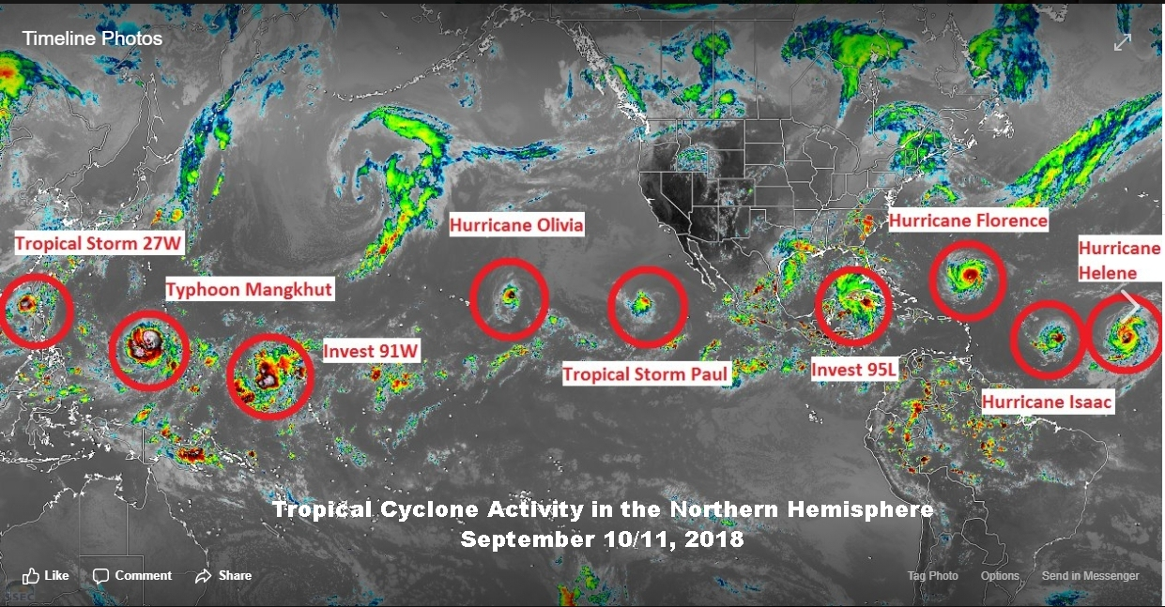

ESCAP/WMO Typhoon Committee

13th Integrated Workshop

Chiang Mai, Thailand

5 to 8 November 2018

**_______________________________________**

**Cover caption**: September 2018 became unusually very active during a period of ENSO-neutral conditions where tropical cyclone activity occurred on one day stretching across the North Atlantic, the Caribbean/Gulf of Mexico Basin, the North Pacific and into the South China Sea. Image courtesy of Mr. Owen Shieh, Training Officer, Joint Typhoon Warning Center, Hawaii from multi-geostationary images.

**CONTENTS**

**I. Overview of tropical cyclones which have affected/impacted**

**Member’s area since the last Committee Session**

1. Meteorological Assessment (highlighting forecasting issues/impacts).
2. Hydrological Assessment (highlighting water-related issues/impact)
3. Socio-Economic Assessment (highlighting socio-economic and DRR issues/impacts)
4. Regional Cooperation Assessment (highlighting regional cooperation success and challenges.

**II. Summary of Progress in Priorities supporting Key Result Areas**

1. Weather Ready Nation Ambassador Program
2. Annual Tropical Cyclone Exercises
3. Tropical Cyclone Workshops
4. StormReady® and TsunamiReady® Programs
5. Outreach and Education Activities
6. Pacific International Training Desk
7. Resource Mobilization During Extreme Events
8. Capital Improvements in Micronesia
9. Improved Typhoon-related Disaster Risk Management in Various Sectors
10. Technological Improvements

**I. Overview of tropical cyclones which have affected/impacted Member’s area since the last Committee Session**

The Pacific Region of the United States of America (USA) National Oceanic and Atmospheric Administration (NOAA) National Weather Service (NWS) encompasses both the western North Pacific Islands in Micronesia (except Kiribati) and the Central Pacific areas. In Micronesia, the USA tropical cyclone activities involve the NWS Pacific Region and the Department of Defense Joint Typhoon Warning Center (JTWC) located at Pearl Harbor, Hawaii. The NWS Weather Forecast Office (WFO) on Guam provides weather forecasts, watches, warnings and advisories within its area of responsibility (AOR). The WFO Guam AOR roughly expands from 130 Degrees East Longitude to the International Date Line and covers an ocean area of more than 4 million square miles (about 10.4 million square kilometers) and more than 2000 Micronesian islands. This includes the Commonwealth of the Northern Mariana Islands (CNMI), Republic of Palau, Federated States of Micronesia (FSM), Republic of the Marshall Islands, and the U.S. Territory of Guam. The FSM is composed of the States of Chuuk, Yap, Pohnpei, and Kosrae.

When tropical cyclones occur, WFO Guam provides the warnings for the U.S. Affiliated Islands of Micronesia. The WFO Guam uses the track, intensity and wind distribution information provided by JTWC to produce plain language forecast and warning products informing the general public and governmental agencies of impending severe weather.

The Central Pacific Hurricane Center (CPHC) is co-located with the NWS Forecast Office in Honolulu. The NWS Forecast Office in Honolulu activates the CPHC when tropical cyclones form in, or move into, the Central Pacific region from 140 Degrees West Longitude to the International Date Line. CPHC is also the Regional Specialized Meteorological Center (RSMC) for tropical cyclones in this region and in this capacity is known as RSMC Honolulu.

The NWS Forecast Office in Honolulu’s AOR covers around 5 million square miles (about 13 million square kilometers) generally from the Equator to 30N between 140W and 160E.

1. **Meteorological Assessment (highlighting forecasting issues/impacts)**

***Western North Pacific (130E to 180, north of the equator) Overview***

A total of 30 tropical cyclones entered or formed in the WFO Guam AOR from October 2017 to September 2018. Continuing from the summer of 2017 with weak La Nina/ENSO-neutral conditions, tropical cyclone activity for the rest of 2017 remained slightly below average. Similar to earlier in the year, the majority of tropical cyclones, except for Typhoon Saola (27W), formed in the western portion of the AOR. Typhoon Saola was the only tropical cyclone that required a watch or warning in the WFO Guam AOR in all of 2017 (two tropical storm watches were issued during the unusual initial stages of development and movement). The only other significant tropical cyclone that formed during this time-period was Super Typhoon Lan (25W) which was warned on by JTWC after it passed west of Yap and Ngulu, in Yap State.

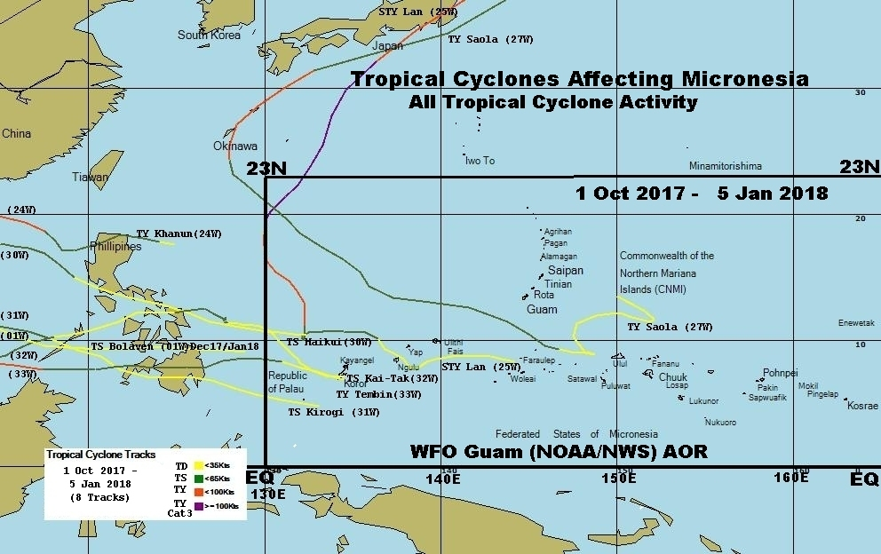

Figure 13: Tropical Cyclones affecting Micronesia from October 1, 2017

The year 2018 has remained in ENSO-neutral conditions through September and as such, tropical cyclone activity has been above average with activity occurring in every month except April. For ease of display, the two maps are divided into those cyclones that remained below 100 knot (Category 2 and below) and those that became major typhoons (Category 3 and above). The map for the weaker tropical cyclones primarily shows formation in the central to western portion of the AOR and, except for the early season, Tropical Storm Sanba (02W), movement was initially to the northwest or north. In this group, only Tropical Storm Sanba (in February) required tropical storm watches or warnings: in western Yap State and in the Republic of Palau. Here, only the southern islands of Palau reported weak tropical storm conditions and some island flooding, but with no significant damage.

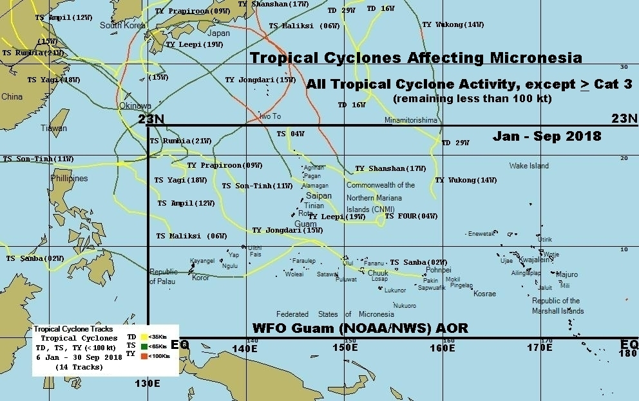

Figure 2: Tropical Cyclones less than 100 knot affecting Micronesia from January 6 to September 30, 2018.

The map of stronger tropical cyclones shows a significant change in formation and development from past several years. Except for Typhoon Jelawat (03W) in March which required tropical storm watches and warnings for islands in Yap State and the Republic of Palau, and again a tropical storm watch for the northern islands of the CNMI as it made its extratropical transition, the remaining tropical cyclones formed farther east and deeper in the tropics than any in the past two years. By mid-August, strong tropical cyclones began to form east of Guam every 7 to 10 days through the end of September. All tropical cyclones in this group required watches and warnings for islands in the Marianas (Guam and the CNMI). Of significance, Super Typhoon Maria (10W) went over Guam in July as a strong tropical storm and Super Typhoon Mangkhut (26W) made a direct hit over Rota in September as a strong Category 2 typhoon bringing significant structural and agricultural damage to the island, while bringing near typhoon conditions as far south as central Guam. Finally, Super Typhoon Jebi (25W) passed just north of the sparsely populated island of Pagan in September as a Category 5 typhoon (140 knot) but was well warned and presented no serious injuries. However, there were considerable plant and agricultural destruction.

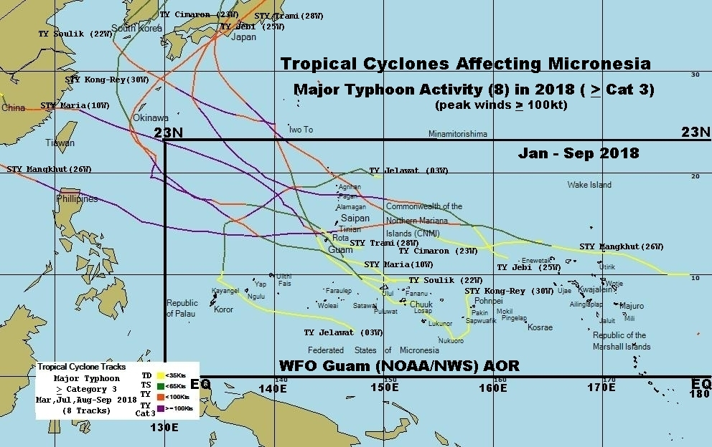

Figure 3: Tropical Cyclones at least 100 knot affecting Micronesia from January 6 to September 30, 2018.

***Central North Pacific (140W to 180, North of the Equator) Overview***

Six tropical cyclones entered into, or were generated in, the central North Pacific during the period from January 1 through September 30, 2018.   These were: Hurricane Hector, Hurricane Lane, Hurricane Miriam, Hurricane Norman, Hurricane Olivia and Hurricane Walaka.

Hurricane Hector developed in the Eastern Pacific basin and moved into the Central Pacific Hurricane Center AOR on August 6 as a 120 knot major hurricane.  Hector moved westward along the 15N to 17N latitude bringing high surf to the south and east facing shores of the Hawaiian Islands as it passed south of the state. Hector weakened to a tropical storm and crossed into the RSMC Tokyo area of responsibility on August 13.

Hurricane Lane also developed in the Eastern Pacific basin and then moved into the Central Pacific on August 18 as a 115 knot major hurricane.  Lane tracked further to the west-northwest, briefly strengthened to a Category 5 hurricane on August 21, and then turned northward just west of the Big Island of Hawaii still as a major hurricane.   Lane’s forward speed slowed to a crawl and began to weaken to the south of Oahu, before upper level winds sheared the cyclone. The weakened Lane then moved to the west away from the state of Hawaii.  The main impacts from Lane was severe flash flooding from 40 to 50 inches of rainfall over the Big Island. Lesser, but still severe flooding was also noted on the island of Maui. Lesser impacts to Oahu were observed with minor flooding and localized wind damage.

Hurricane Miriam also developed in the Eastern Pacific basin, moving into the Central Pacific on August 29 as a 65 knot hurricane.   Miriam weakened rapidly to a Tropical Storm a few days after moving into the area near 142W as the cyclone turned north and dissipated.

Hurricane Norman crossed from the Eastern Pacific into the Central Pacific on September 3 as a 75 knot hurricane at nearly 20N and 140W.  This high latitude cyclone fluctuated in intensity as it moved nearly due westward, then turn northwest as it reached 150W. Norman weakened to a tropical storm on September 7 and became a post-tropical low on September 8 far to the north of the Hawaiian Islands.

Hurricane Olivia crossed into the Central Pacific basin on September 8 as a 70 knot hurricane at nearly 22N 140W.  Olivia made a westward trek along that high latitude similar to Norman, maintaining hurricane status until reaching 150W where it weakened to tropical storm strength.  As a tropical storm, Olivia made two landfalls in the Hawaiian Islands on September 12. Once on the Island of Maui near Kahakuloa, 10 miles northwest of Kahului, and a second landfall was recorded a short time later on the Island of Lanai, 6 miles north-northeast of Lanai City.   Olivia continued to weaken and became a post-tropical cyclone on September 13. Impacts to the Hawaiian Islands included, torrential rains and severe flash flooding on Maui and Molokai Islands, with some scattered wind damage and power outages on Maui, Molokai, and Oahu.

Hurricane Walaka developed in the Central Pacific on September 29 about 680 miles south of Honolulu.  Walaka eventually strengthened rapidly to a category 5 hurricane and the eastern eyewall moving directly across Johnston Island (uninhabited at the time) on October 2.  Walaka accelerated northward but remained a major hurricane as it moved across the Papahanaumokuakea Marine National Monument on October 3. Walaka weakened rapidly as it continued northward over cooler waters and eventually became a post-tropical low on October 6 near 36N 164W.

The remainder of the season has remained largely quiet for tropical cyclone activity with persistent, but disorganized convection developing along the Intertropical Convergence Zone in the persistent northern hemisphere easterlies.

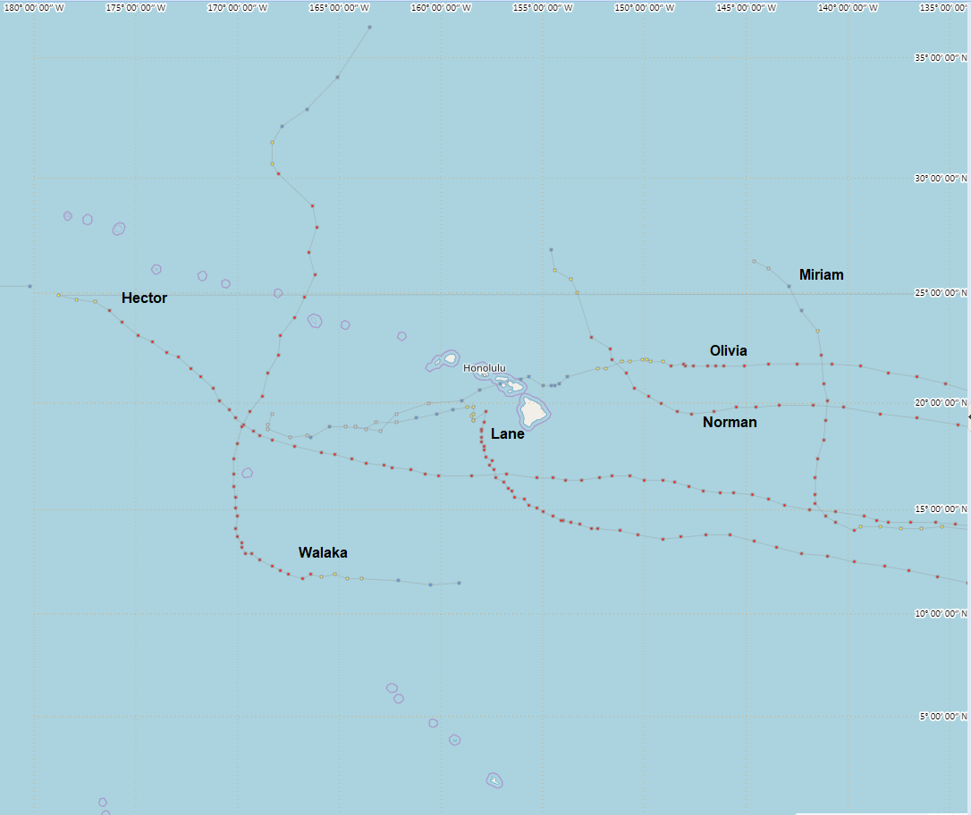

Figure 4: Central North Pacific Tropical Cyclone tracks: January 1 to September 30, 2018

2. **Hydrological Assessment (highlighting water-related issues/impact)**

***Western North Pacific (130E to 180, north of the equator) Overview***

The end of 2017 saw fairly normal to slightly above normal rainfall across the Marianas and Micronesia as a few tropical systems moved through the region as tropical disturbances before developing into tropical storms or typhoons north and west of the islands. The end of 2017 and beginning of 2018 saw a weak La Nina pattern. La Nina reverted to ENSO-neutral by May, with an El Nino watch being issued for the winter of 2018-2019. Dry conditions developed over the northern Marshall Islands and the Marianas from the end of January through around mid-April, when beneficial rains eased the water shortage.  Drought Information Statements (DGT) were provided by the WFO Guam on a bi-weekly basis. Although the drought conditions existed, the drought was not nearly as severe as the previous year. A total of 10 Drought Information Statements were issued during this period.

Several tropical systems affected the region from February (Tropical Storm Sanba, 02W, in Chuuk, Yap and Palau) through the end of September (what became Super Typhoon Kong-Rey, 30W, affecting Chuuk and Guam). Super Typhoon Mangkhut (26W), brought heavy rains to Guam and Rota, resulting in Flash Flood Warnings being issued for both islands. Extensive flooding closed numerous roads and damaged homes and property across Guam, especially in the village of Merizo. High water exacerbating the damage received by Rota as Mangkhut moved across the island.

***Central North Pacific (140W to 180, North of the Equator) Overview***

The main Hawaiian Islands experienced record-breaking wet conditions in August and September as a result of tropical cyclone activity and other weather disturbances. On average across Hawaii, it was the second wettest summer period in the last 30 years. This eliminated a drought for the entire state of Hawaii in early October following vegetation recovery.

**3. Socio-Economic Assessment (highlighting socio-economic and DRR issues/impacts)**

***Western North Pacific (130E to 180, north of the equator) Overview***

WFO Guam conducted formal presentations for emergency managers and military decision makers that included representatives from the Federal Emergency Management Agency (FEMA) and the United States Agency for International Development (USAID), the two key US agencies for emergency recovery, relief, and mitigation program assistance. The WFO also conducted more than two hundred radio and television interviews, more than 100 outreach educational events that at least in-part addressed tropical cyclones, and 40 operational Tropical Cyclone briefings to Emergency Managers. WFO Guam also utilized social media to greatly increase its reach to the general public. In fact, tropical cyclone information was accessed four times as often through Facebook as through the WFO Guam website.

WFO Guam also provided specially tailored, comprehensive 16-module, 2-day Tropical Cyclone, Disaster preparedness and Climate Workshops at four different locations in 2018. These locations included Guam, Saipan and Rota in the CNMI, and Chuuk in the FSM. Twelve of the modules addressed tropical cyclones or some aspect of tropical cyclones.

***Central North Pacific (140W to 180, North of the Equator) Overview***

RSMC Honolulu conducted over 100 tropical cyclone related outreach events, several hundred broadcast and print media interviews, and over 100 formal emergency manager briefings. Also in 2018, RSMC Honolulu presented onsite Hurricane Preparedness for Decision Makers training at the various federal, state and county emergency management agencies in coordination with U.S. FEMA. This approach resulted in a larger outreach to the various emergency management functions in each agency. In addition, RSMC Honolulu participated in two separate week-long hurricane exercises by providing maps, advisories and briefings. For all events, RSMC Honolulu emphasized that a direct landfall is not necessary to produce major damage and impacts, as well as new products and services.

**4. Regional Cooperation Assessment (highlighting regional cooperation success and challenges.**

None.

**II. Summary of Progress in Priorities supporting Key Result Areas**

1. **Weather Ready Nation Ambassador Program**

**Main text:**

Striving for community resilience at a national scale is a major goal for the NOAA National Weather Service. Since embarking on the Weather Ready Nation program and expanding it to include the Ambassador Initiative in 2014, NOAA and its partners are moving to make the country weather-resilient.

As a WRN Ambassador, partners commit to working with NOAA and other Ambassadors to strengthen national resilience against extreme weather. Throughout 2018, the WRN Ambassador initiative helped and continues to help unify the efforts across government, non-profits, academia, and private industry toward making the nation more ready, responsive, and resilient against extreme environmental hazards.  This year alone, WFO Guam registered at least 125 Ambassadors on Guam, the CNMI, and the FSM.

**Identified opportunities/challenges, if any, for further development or collaboration:**

NWS will continue to use the opportunity to engage in multilateral forums and engage with partners in international agreements to help infuse the global weather enterprise with our new weather and climate information, new science, and innovative technology and seek opportunities to learn best practices from other countries to improve our technology and service delivery.  We will expand our partnerships to help improve and sustain observing and communications networks essential for early warnings.

**Priority Areas Addressed:**

Strengthen typhoon-related disaster risk reduction activities in various sectors, including increased community-based resiliency with better response, communication, and information sharing capability.

**Contact Information:**

|  |  |  |
| --- | --- | --- |
| Member: | USA - Guam | USA - Hawaii |
| Name of contact for this item: | Marcus Aydlett | John Bravender |
| Telephone: | (671) 472-0952 | (808) 973-5275 |
| Email: | marcus.aydlett@noaa.gov | john.bravender@noaa.gov |

1. **Annual Tropical Cyclone Exercises**

**Main text:**

Annual tropical cyclone exercises were conducted by the Government of Guam, Government of the CNMI, Federated States of Micronesia and the State of Hawaii with participation by US National Weather Service Offices at Honolulu and Guam and the US FEMA in order to maintain a level of skill and situational awareness when dealing with tropical cyclones.

WFO Guam participated in the island-wide typhoon exercises for Guam and for the CNMI in June and for Chuuk FSM in September. RSMC Honolulu participated in two statewide annual tropical cyclone exercise in Hawaii.  Both annual hurricane exercises, one coordinated by Hawaii Emergency Management Agency (HEMA) in partnership with the NWS Forecast Office in Honolulu, the other by the Hawaii National Guard, were held in June.

**Identified opportunities/challenges, if any, for further development or collaboration:**

With staff turnovers affecting every agency, it is important to maintain these exercises such that all persons remain skilled and ready in the event of a real disaster.

**Priority Areas Addressed:**

Enhance capacity to generate and provide accurate, timely and understandable information using multi-hazard impact-based forecasts and risk-based warnings, watches, and advisories.

Strengthen typhoon-related disaster risk reduction activities in various sectors, including increased community-based resiliency with better response, communication, and information sharing capability.

**Contact Information:**

|  |  |  |
| --- | --- | --- |
| Member: | USA - Guam | USA - Hawaii |
| Name of contact for this item: | Charles Guard | John Bravender |
| Telephone: | (671) 472-0946 | (808) 973-5275 |
| Email: | chip.guard@noaa.gov | john.bravender@noaa.gov |

1. **Tropical Cyclone Workshops**

In the western North Pacific, WFO Guam conducts their Annual Tropical Cyclone, Disaster Preparedness and Climate Workshop. These two-day workshops are tailored for each island and designed for decision makers in the local, state, and national governments and agencies.

The Workshops cover a plethora of topics such as:

* tropical cyclone behavior, structure, and hazards;
* the WFO Guam tropical cyclone program, products, and timing of products;
* tropical cyclone plotting and speed-distance-time computations;
* typhoon risk and vulnerability; a scale that relates tropical cyclone wind speed to damage and storm surge;
* tropical cyclone decision making for individual islands and states; and
* WFO Guam website products.
* In addition, topics on general climate familiarity, climate variability, and climate change; El Niño /La Niña and their effects, impacts and status are covered. Other subjects addressed were tsunamis and volcanoes; rip currents, currents, and tides; and earthquakes upon the request of the participants.

In 2018, WFO Guam conducted workshops in Rota and Saipan, CNMI, Guam, and Chuuk in the FSM. Scheduling difficulties and travel restrictions prevented the WFO Guam staff from achieving total visitation to all of Micronesia.

**Identified opportunities/challenges, if any, for further development or collaboration:**

Primary means of educating decision makers of all agencies and ensuring that the information continually updated.

**Priority Areas Addressed:**

Enhance capacity to generate and provide accurate, timely and understandable information using multi-hazard impact-based forecasts and risk-based warnings, watches, and advisories.

Strengthen typhoon-related disaster risk reduction activities in various sectors, including increased community-based resiliency with better response, communication, and information sharing capability.

**Contact Information:**

|  |  |
| --- | --- |
| Member: | USA - Guam |
| Name of contact for this item: | Charles Guard |
| Telephone: | (671) 472-0946 |
| Email: | chip.guard@noaa.gov |

1. **StormReady® and TsunamiReady®**    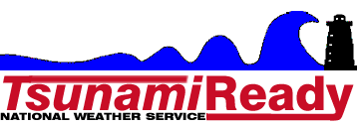

StormReady® is a program designed by the National Weather Service to help communities and counties implement procedures and supplemental programs to reduce the potential for disastrous, weather-related consequences. StormReady® helps communities evaluate their current levels of preparedness for and response to extreme weather-related events.  These communities demonstrate a strong commitment to saving lives and protecting property when hazardous weather strikes.  By participating in StormReady®, local agencies can earn recognition for their jurisdiction by meeting guidelines established by the NWS in partnership with federal, state and local emergency management professionals.  TsunamiReady® is a similar program that expands preparedness and response of coastal communities to tsunami threats. After the initial recognition, communities can reapply every 3 years.

In October 2017, the island of Tinian, CNMI was recognized for another three years as a StormReady® and TsunamiReady® location. This designation was tested when Typhoons Maria, Mangkhut, Jebi, and Trami tracked toward the CNMI. Tinian, Saipan and Rota Emergency Management offices went into action and adequately warned their populace, preventing any injury and unnecessary destruction of property.

In April 2018, the US Naval Base on Guam was re-evaluated and recognized for another three years. Because the military base functions as its own community and does not have an on-island Navy weather presence, it is an important recognition for the Department of Defense. This is the second military base on island to receive this recognition.

The Guam civilian community has been StormReady® and TsunamiReady® since June 2006. In June 2018, the community underwent a full re-evaluation (conducted every 6 years) and was again recognized. Guam also exercised its tropical cyclone readiness during Typhoons Maria, Mangkhut and Trami.

RSMC Honolulu assisted the needs of the 19 StormReady® and TsunamiReady® communities across the State of Hawaii in 2018. This included ensuring each community had disaster action plans in place and held outreach events to convey a preparedness message.

**Identified opportunities/challenges, if any, for further development or collaboration:**

As of October 3, 2018, there were 2887 StormReady® communities and 201 TsunamiReady® communities in the United States, of which, 17 of each are in the Pacific Region. All of the locations under the WFO Guam AOR are both StormReady® and TsunamiReady®.

**Priority Areas Addressed:**

Strengthen typhoon-related disaster risk reduction activities in various sectors, including increased community-based resiliency with better response, communication, and information sharing capability.

**Contact Information:**

|  |  |  |
| --- | --- | --- |
| Member: | USA - Guam | USA - Hawaii |
| Name of contact for this item: | Charles Guard | John Bravender |
| Telephone: | (671) 472-0946 | (808) 973-5275 |
| Email: | chip.guard@noaa.gov | john.bravender@noaa.gov |

1. **Outreach and Education Activities**

**Main text:** Numerous outreach and education activities conducted in 2018 include:

* *Expanded Pacific Hydrology Discussions.* Both WFO Guam and RSMC Honolulu provide input into the quarterly *Pacific ENSO Update* newsletter produced by the Pacific ENSO Applications Climate Center, which issues Special Updates, if warranted. WFO Guam also provides input to the Climate Prediction Center’s Monthly *ENSO Diagnostics Discussion* and employs the use of more comprehensive and targeted products--the *Hydrologic Outlook* product for extreme rainfall events and the *Drought Information Statement* for drought events. Finally, WFO Guam and RSMC Honolulu assist in preparing a popular quarterly two-page color product called the *Hawaii and U.S. Pacific Islands Climate Impacts and Outlook*.
* *RSMC Press Conference.* RSMC Honolulu hosted a press conference to announce the 2018 Central Pacific Hurricane Season Outlook on 26 May.

* *RSMC Honolulu media interfaces.* RSMC Honolulu conducted in the neighborhood of a thousand media interviews, teleconferences and press briefings throughout the season as several of the tropical cyclones had impacts to the Hawaiian Islands in order to provide decision makers with useful and timely information about developing hazards.
* *University Course Enhancement.* Nine times during the period, WFO Guam hosted the University of Guam Environmental Biology and Physical Geography classes providing facility tours and seminars on tropical cyclones, ENSO, and Climate Change. This provided education to students majoring in such topics as nursing, education, criminal justice, and biological sciences. RSMC Honolulu hosts twice weekly weather discussions involving students and professors of the University of Hawaii (UH) Department of Meteorology, which engages the students in operational weather application focusing on societal impacts. At least three forecast personnel and management have been invited as guest instructors at university classes at UH and Leeward Community College.
* *National Disaster Preparedness Month.*  September is declared National Disaster Preparedness Month in the USA. WFO Guam participates in outreach activities sponsored by the Guam Homeland Security and the CNMI Homeland Security. However, typhoons Mangkhut, Trami, and Kong-rey curtailed a lot of the planned events. Instead, the islands got to experience disaster preparedness first hand with these three cyclones in the month.
* *FEMA 2018 Service Learning, Youth and Community Preparedness Summit”.*   The FEMA Youth Preparedness Council along with the Guam Youth Preparedness Program hosted a seminar on disaster preparedness with community action. The objective was “equipping and empowering the youth of today, makes a more resilient and better prepared island of Guam tomorrow.” WFO Guam provided the lectures on climate and climate change and tropical cyclones and preparedness.

**Identified opportunities/challenges, if any, for further development or collaboration:**

Outreach events are fundamental in training the general population in disaster preparedness that eventually leads to a more resilient population.

**Priority Areas Addressed:**

Strengthen typhoon-related disaster risk reduction activities in various sectors, including increased community-based resiliency with better response, communication, and information sharing capability.

**Contact Information:**

|  |  |  |
| --- | --- | --- |
| Member: | USA - Guam | USA - Hawaii |
| Name of contact for this item: | Charles Guard | John Bravender |
| Telephone: | (671) 472-0946 | (808) 973-5275 |
| Email: | chip.guard@noaa.gov | john.bravender@noaa.gov |

1. **Pacific International Training Desk**

**Main text:**

The Pacific International Training Desk (PITD) was established on the campus of the University of Hawaii at Manoa in 2001 by the US NOAA/NWS at the Weather Forecast Office (WFO) Honolulu. The Pacific Desk is one of NOAA’s contributions to the World Meteorological Organization (WMO) Voluntary Cooperation Program (VCP). The Pacific Desk began by offering two-month training internships to visiting students from the Regional Association V (RA V) of the WMO in March 2001 and later expanded the training opportunity briefly to developing countries from WMO RA II nations in east and Southeast Asia, who were also members of the ESCAP/WMO Typhoon Committee. Up until 2016, all the PITD training were conducted at the RSMC Honolulu. In 2016, the PITD training reached out to include the Weather Service Offices in Micronesia and as of 2018, a total of 40 students have completed the training.

The PITD consists of four components:  1) basic forecaster training, to be implemented through use of e-learning modules that will be readily available to anyone; 2) a month long, instructor led onsite training program carried out at RSMC Honolulu and/or WFO Guam; 3) training on use of communications equipment, also to be funded by the VCP: and 4) in-Island workshops on severe weather event topics.

**Identified opportunities/challenges, if any, for further development or collaboration:**

Regarding the Micronesia Weather Service Offices, all personnel will have completed the training by early 2019. After which the second phase of the PITD in Micronesia will gradually progress into more detailed topics and forecasting techniques for their jurisdictions.

**Priority Areas Addressed:**

Enhance capacity to generate and provide accurate, timely and understandable information using multi-hazard impact-based forecasts and risk-based warnings.

Enhance Typhoon Committee’s Regional and International collaboration mechanism.

**Contact Information:**

|  |  |  |
| --- | --- | --- |
| Member: | USA - Guam | USA - Hawaii |
| Name of contact for this item: | Genevieve C. Miller | Christopher Brenchley |
| Telephone: | (671) 472-0944 | (808) 973-5273 |
| Email: | genevieve.miller@noaa.gov | christopher.brenchley@noaa.gov |

1. **Resource Mobilization During Extreme Events**

**Main text:**

RSMC Honolulu conducted several Emergency Management Briefings during 2018 hurricane season through video teleconferencing. These briefings included personnel at Emergency Operations Centers from the State level to the local level with the State Governor and County Mayors participating at times.

RSMC Honolulu also provided onsite decision support to the State of Hawaii Emergency Operations Center through dispatch of a meteorologist during the threats from Hurricane Lane and Hurricane Olivia in August and September of 2018.

WFO Guam provided onsite decision support services deployed to the Guam Homeland Security/Civil Defense Joint Information Center during Typhoons Maria and Mangkhut and Tropical Storm 28W. These particular heavy weather briefings are primarily catered for the island leadership and military decision makers on potential tropical cyclone threats. For locations outside of Guam, WFO Guam also prepared tailored briefing slides for the CNMI leadership and the Emergency Management Office, and then provided an accompanying telephonic briefing on those slides.

**Identified opportunities/challenges, if any, for further development or collaboration:**

Impact-based decision support services are made available to local decision makers especially in locations that lack meteorological support and knowledge.

**Priority Areas Addressed:**

Enhance capacity to generate and provide accurate, timely and understandable information using multi-hazard impact-based forecasts and risk-based warnings

Strengthen typhoon-related disaster risk reduction activities in various sectors, including increased community-based resiliency with better response, communication, and information sharing capability.

Enhance Typhoon Committee’s Regional and International collaboration mechanism.

**Contact Information:**

|  |  |  |
| --- | --- | --- |
| Member: | USA - Guam | USA - Hawaii |
| Name of contact for this item: | Genevieve C. Miller | Christopher Brenchley |
| Telephone: | (671) 472-0944 | (808) 973-5273 |
| Email: | genevieve.miller@noaa.gov | christopher.brenchley@noaa.gov |

1. **Capital Improvements to Weather Service Offices in Micronesia**

**Main text:**

Capital improvements to two Weather Service Offices in Micronesia were completed in 2018. The improvements will benefit the countries and enable the WSO staff to better support the weather needs and warnings for their islands.

The Weather Service Office Koror in the Republic of Palau was relocated to a new building at the Palau International Airport. The new facility, now adjacent to the Airport Rescue and Fire Fighting, is about 2925 square foot (272 square meter) including an upper air inflation building for radiosonde launches. It is the first station in Micronesia to use the Transitional Radiosonde Operating System (TROS) which uses a 1680 MHz upper air frequency to a 403 MHz that is more in line with other upper air stations across the world. Also among the upgrades was the additional hydrogen generator needed to ensure a continuous supply of the inert gas for the upper air balloons. The new building is capable of withstanding 175 mph.

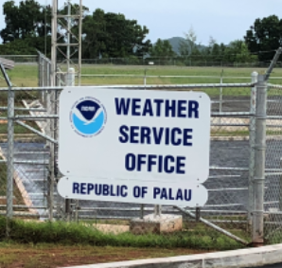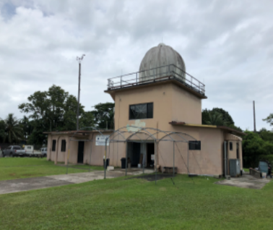

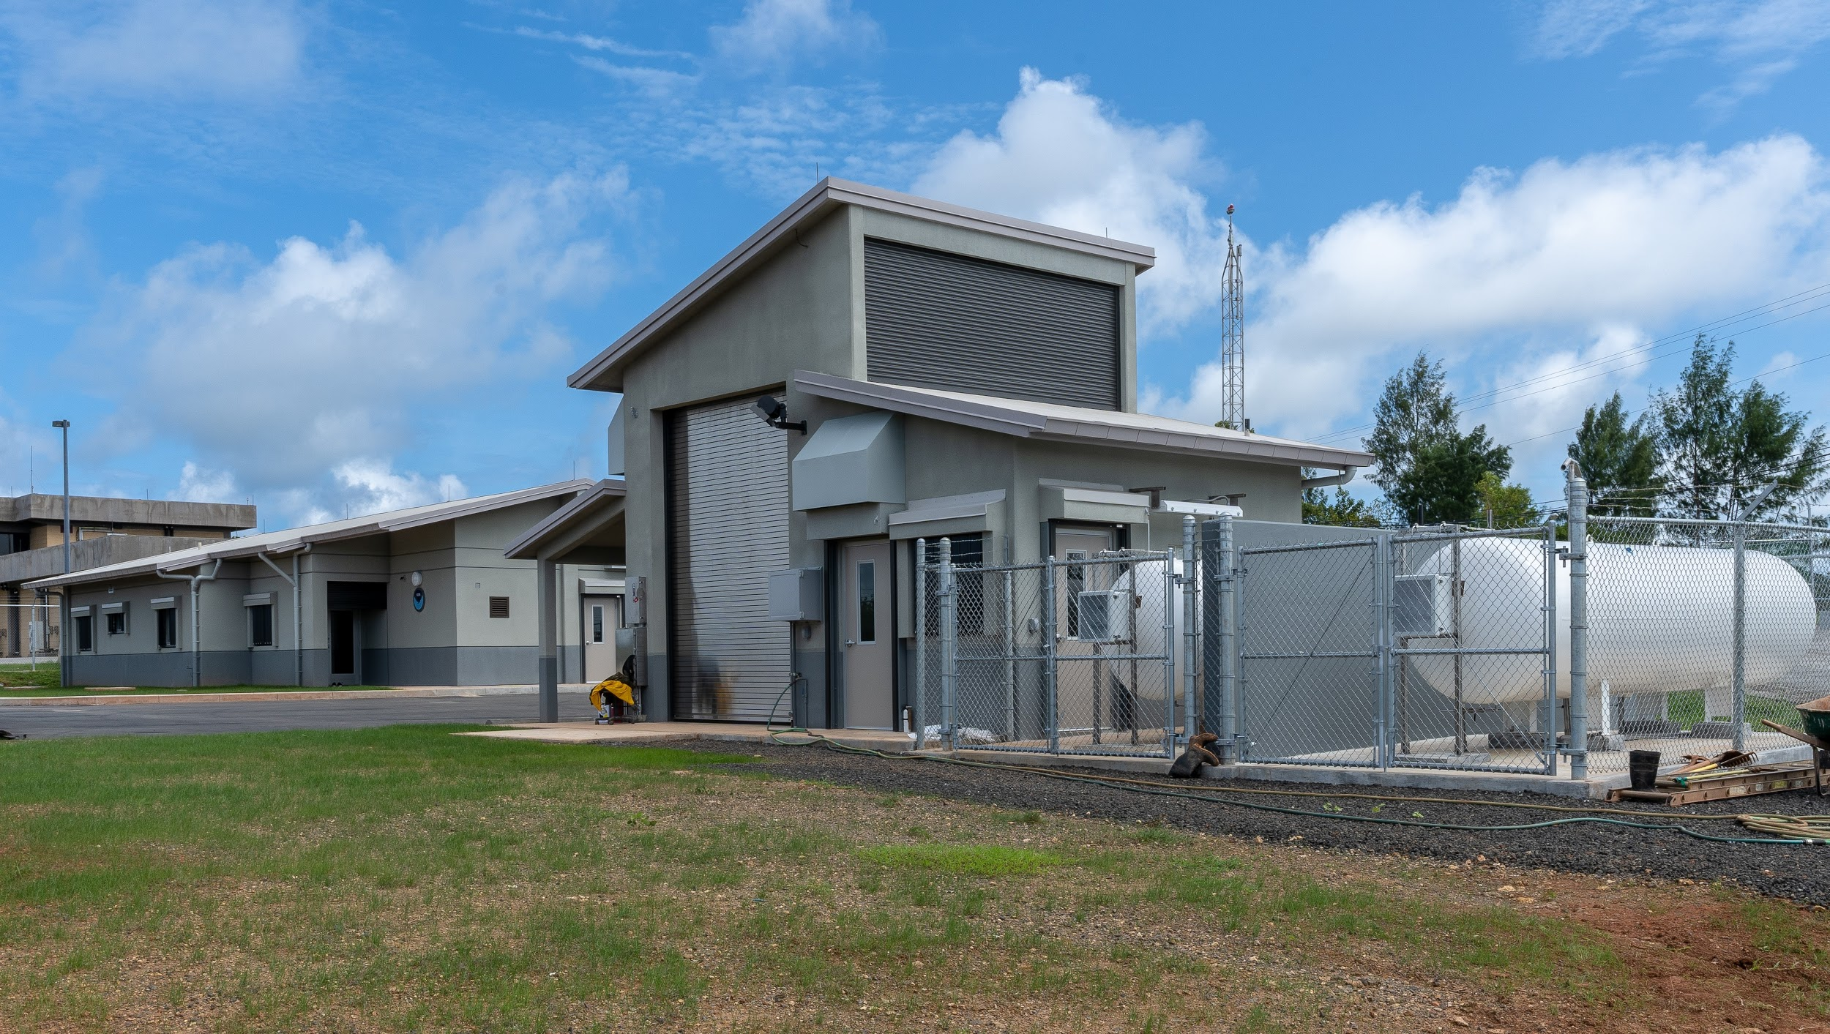

Figure 5: a) Weather Service Office Palau signage, b) old building and c) new building with dual hydrogen generators in the forefront.

The Weather Service Office Chuuk in the Federated States of Micronesia received major upgrades that included expanding the size of the building from a 1775 square foot (165 square meter) building to about 2800 square foot (260 square meter). This expansion included new offices, conference room, kitchen, restrooms, and electrical/communications room. Similar to the WSO Koror, the WSO Chuuk also received an additional hydrogen generator and the facility is hardened to survive 160 mph winds.

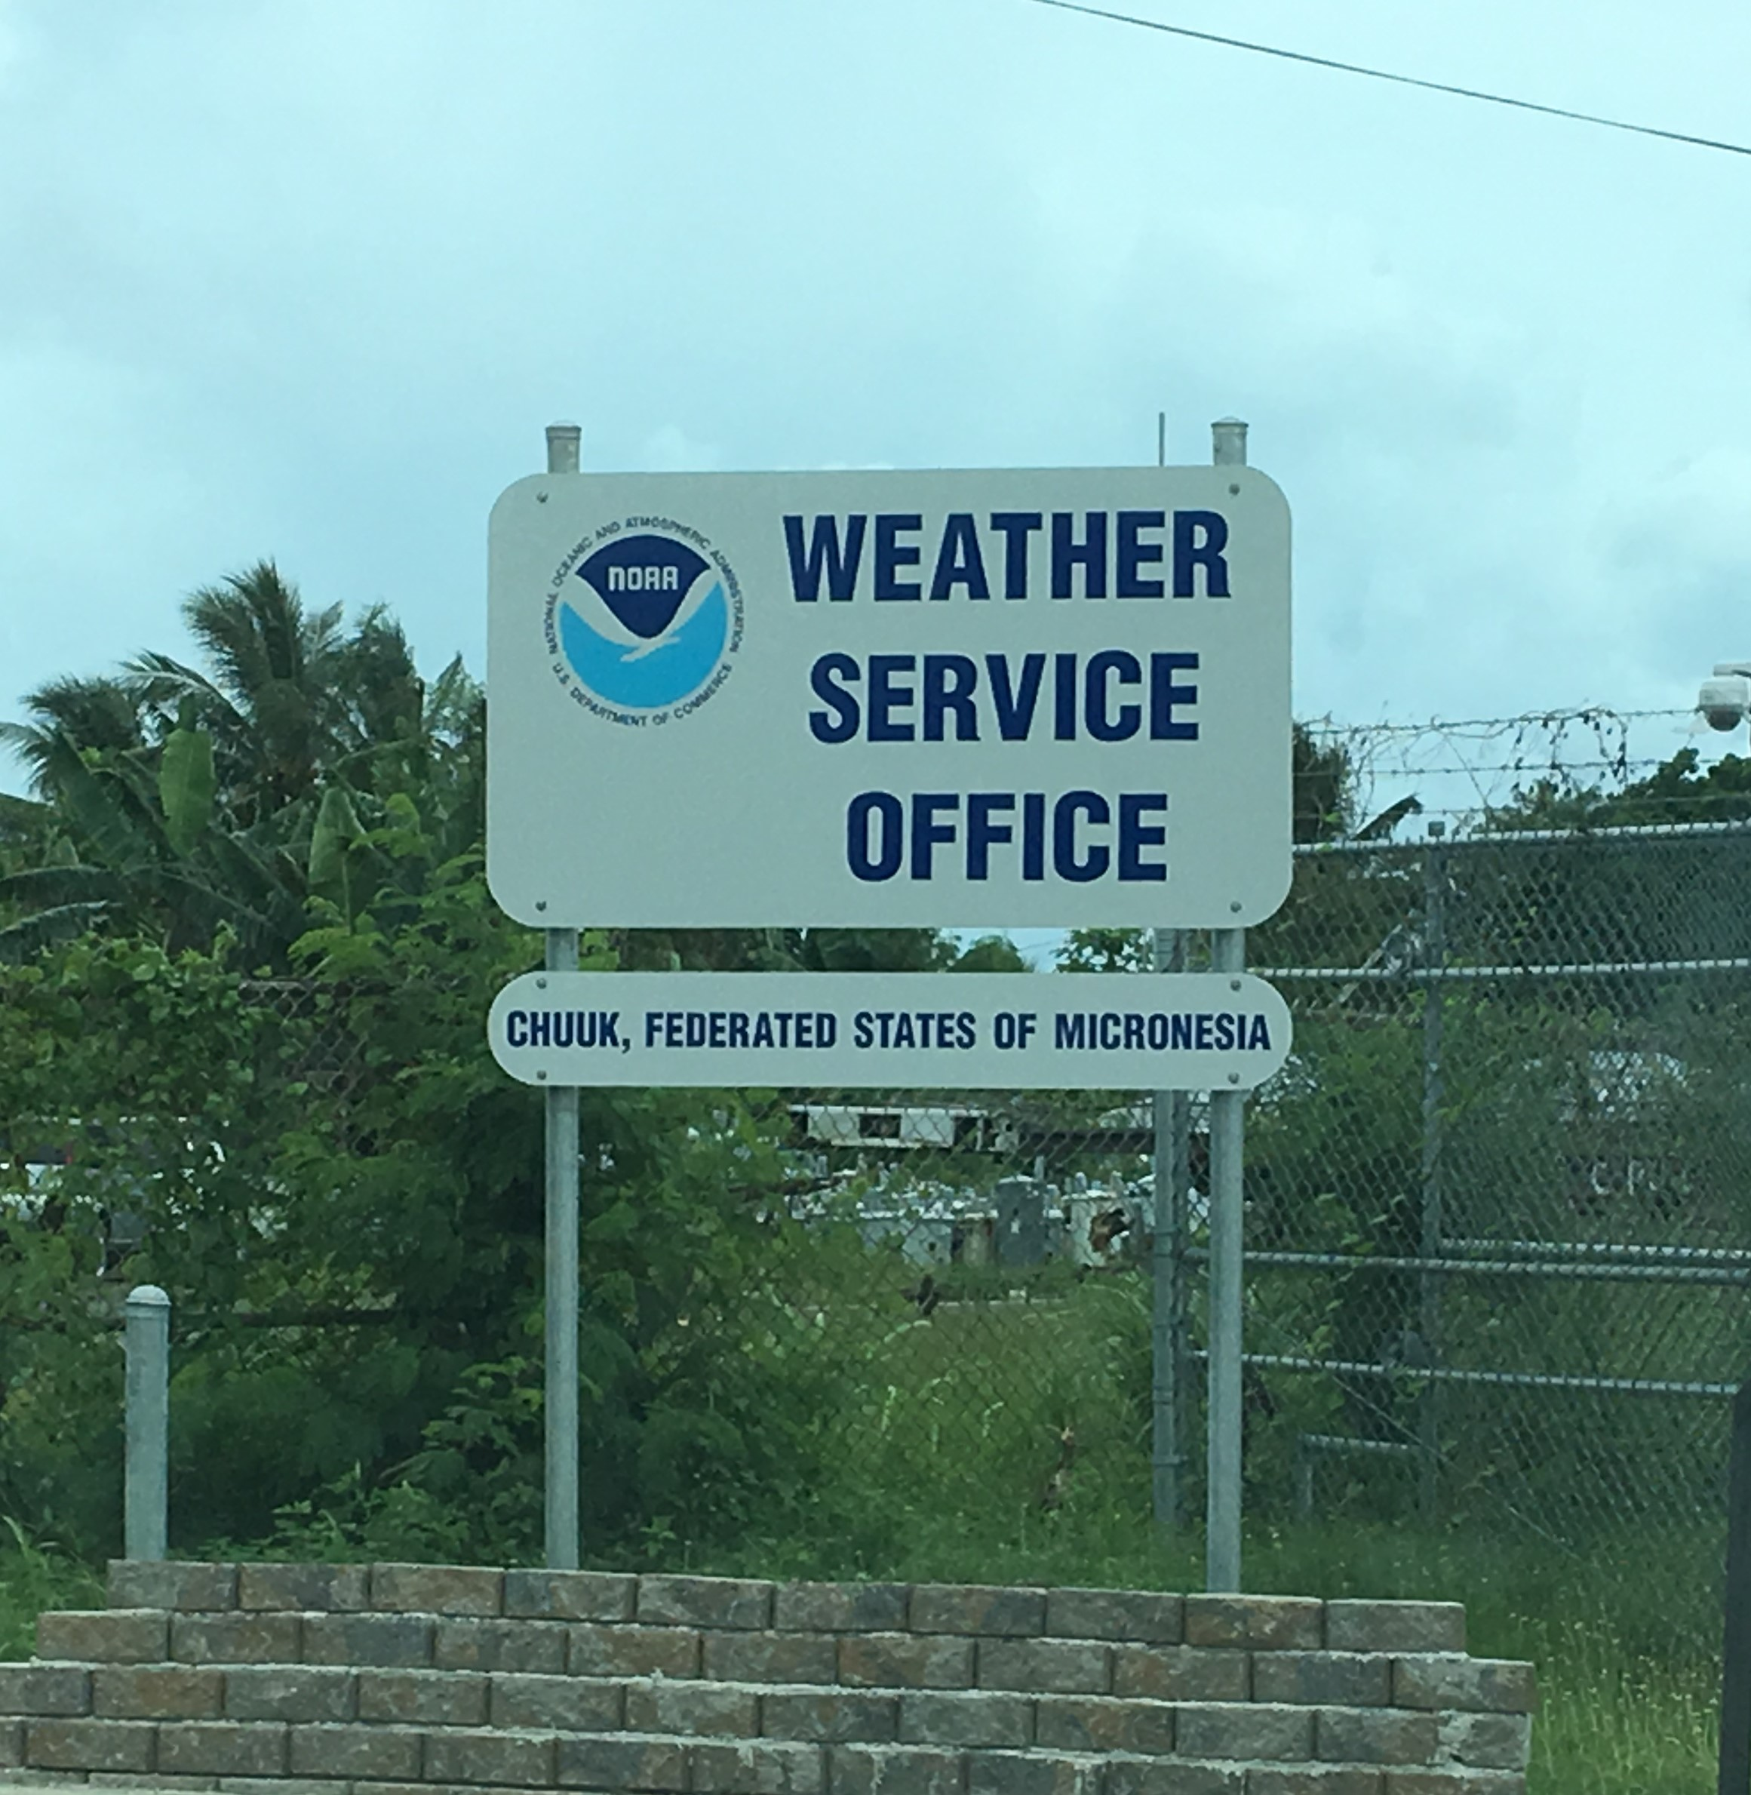 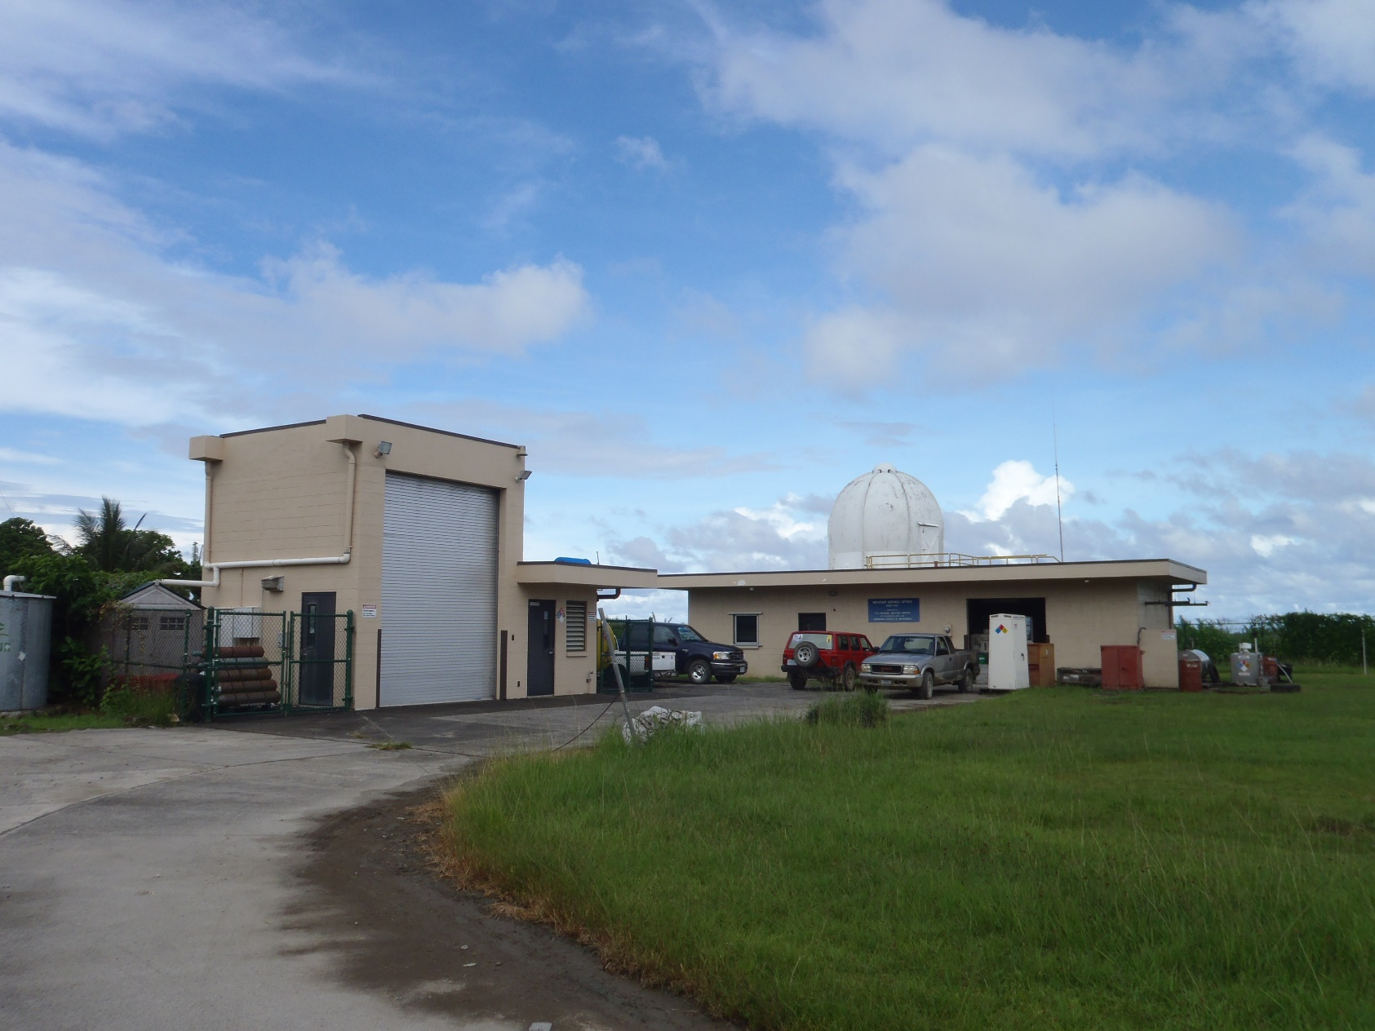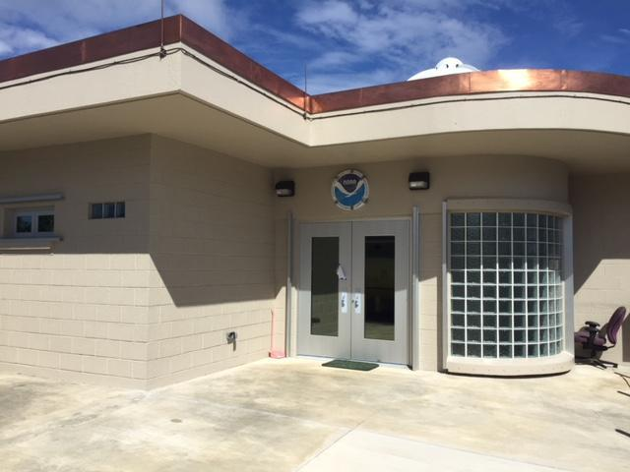 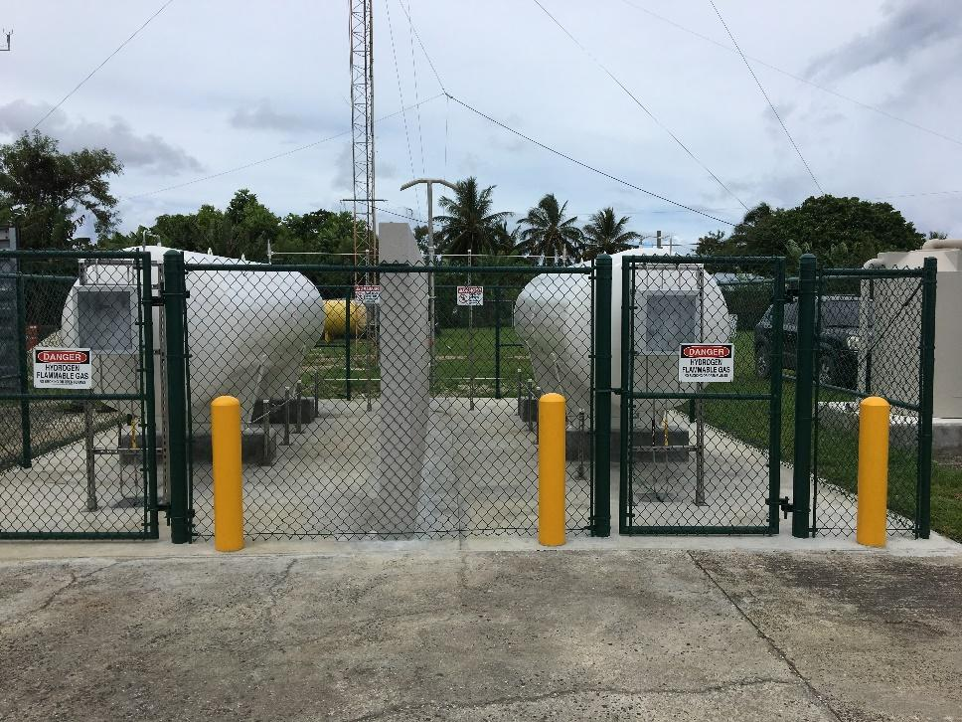

Figure 6: Clockwise from top: a) Weather Service Office Chuuk signage, b) old building, c) dual hydrogen generator, and d) new façade.

**Identified opportunities/challenges, if any, for further development or collaboration:**

Better facilities help improve the forecast and warning services of the office. It is also better set up for additional meteorological studies.

**Priority Areas Addressed:**

Enhance capacity to generate and provide accurate, timely and understandable information using multi-hazard impact-based forecasts and risk-based warnings

Strengthen typhoon-related disaster risk reduction activities in various sectors, including increased community-based resiliency with better response, communication, and information sharing capability.

Enhance Typhoon Committee’s Regional and International collaboration mechanism.

**Contact Information:**

|  |  |  |
| --- | --- | --- |
| Member: | USA - Guam | USA - Hawaii |
| Name of contact for this item: | Genevieve C. Miller | Derek Ching |
| Telephone: | (671) 472-0944 | (808) 725-6030 |
| Email: | genevieve.miller@noaa.gov | derek.ching@noaa.gov |

1. **Improved Typhoon-related Disaster Risk Management in Various Sectors**

**Main text:**

* + *Tropical Weather Outlook graphic.* During the tropical cyclone season, RSMC Honolulu prepares and transmits a text and two graphical *Tropical Weather Outlook* that illustrates the probability of tropical cyclone development in the next 48 hours and 5 days respectively.
  + *Hawaii State Hazard Mitigation Forum.* The Hawaii State Hazard Mitigation Forum, of which RSMC Honolulu is a member, is tasked with maintaining and updating the Hawaii State Hazard Mitigation Plan. Forum members met regularly to discuss hazard threat, risk assessment, and actions which can be taken to mitigate the hazard risk to protect lives and property from loss and destruction during a natural hazard.
  + *Hawaii Emergency Preparedness Executive Consortium (HEPEC).* RSMC Honolulu is a member of the Hawaii Emergency Preparedness Executive Consortium (HEPEC). HEPEC is comprised of emergency managers and disaster mitigation personnel from local, state, and federal agencies. HEPEC meets quarterly to provide updates on current and outstanding threats, both natural and manmade, to the State of Hawaii. RSMC Honolulu Personnel provided a hurricane presentation to the group during the July 2018 and October 2018 meetings.
* *9th Island Sustainability Conference.* The 9th annual Island Sustainability Conference on Guam was held on March 2018 with the objective to inspire change, facilitate action, and provide a venue for sharing, networking, and collaboration of sustainability issues related to the economic, social/cultural, educational, and environmental or energy solutions. WFO Guam Warning Coordination Meteorologist provided a presentation on extreme events in the Pacific concentrating on droughts, typhoons and El Nino and provided an evaluation on downscaled products.

**Priority Areas Addressed:**

Enhance capacity to generate and provide accurate, timely and understandable information using multi-hazard impact-based forecasts and risk-based warnings

Strengthen typhoon-related disaster risk reduction activities in various sectors, including increased community-based resiliency with better response, communication, and information sharing capability.

**Contact Information:**

|  |  |  |
| --- | --- | --- |
| Member: | USA - Guam | USA - Hawaii |
| Name of contact for this item: | Charles Guard | John Bravender |
| Telephone: | (671) 472-0946 | (808) 973-5275 |
| Email: | chip.guard@noaa.gov | john.bravender@noaa.gov |

1. **Technological Improvements**

**Main text:**

* *Software​ ​improvements​ ​for​ ​Emergency​ ​Managers*.​ ​​ ​ ​Hurrevac​ ​(software​ ​for​ ​emergency managers​ ​to​ ​gather​ ​critical​ ​hurricane​ ​forecast​ ​information)​ ​improvements​ ​were again implemented​ ​in the 2018 version of the program. For the western North Pacific, the display now includes warnings and watches issued by WFO Guam.​ A web-based version is being investigated where emergency managers would no longer have to carry the software on a PC.
* *Polar Orbiter Training*. The Joint Polar Satellite System was installed at the WFO Guam in 2017. In April 2018, the University of Wisconsin conducted a workshop for WFO Guam staff and Andersen Air Force Base Weather Squadron. The two day training included the use of the polar orbiter imager sensors, products and applications and microwave data and product applications.
* *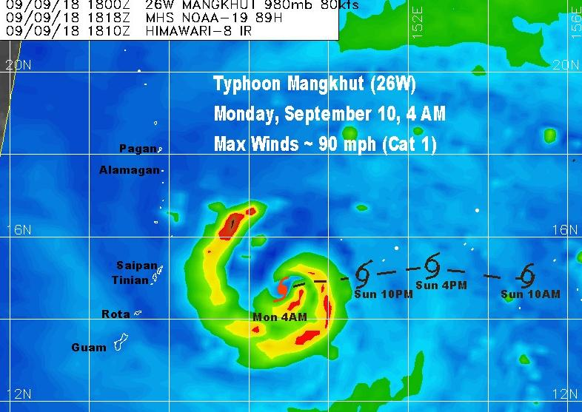Operational use and application​ ​of​ ​ocean​ ​surface​ ​wind​ ​vector from space.* Four international ​scatterometer and wind instruments​: ​ASCAT A and B on board the Metop A and B satellite (EUMETSAT);​ the new OSCAT instrument on board the ScatSat-1 satellite (Indian Space Research Organization, ISRO);​ ​and​ ​Windsat (US Navy and NPOESS program)are continuing to improve near real-time analysis of developing tropical cyclones.​​ ​​These​ ​data​ ​are​ ​made​ ​available​ ​​to​ ​​operational​ ​forecasters by​ ​the​ ​European​ ​Space​ ​Agency​ ​(ESA),​ ​the US NOAA/NESDIS​ ​and​ ​the​ US Navy (FNMOC) and the US​ ​Naval​ ​Research Laboratory, Monterey ​(NRLMRY).​ ​​ While​ ​the data still requires interpretation in​ ​heavy​ ​rainfall​ ​and ​in very​ ​light​ ​and​ ​very strong​ ​wind​ ​conditions, their use has become greatly expanded and integrated with the more traditional geostationary satellite imagery. Satellite-based wind data and high resolution microwave data​ ​greatly​ ​improve​ ​our​ ​capability​ ​to​ ​monitor​ ​tropical cyclone​ ​development​ ​and​ ​to​ ​observe​ ​the​ ​structure​ ​and​ ​intensity​ ​of​ ​tropical​ ​cyclones​ ​in​ ​the AOR (Figures 7 and 8).

Figure 7: AMSU microwave imagery at 89 GHz showing precise south of west track of Typhoon Mangkhut as heads towards the island of Rota.

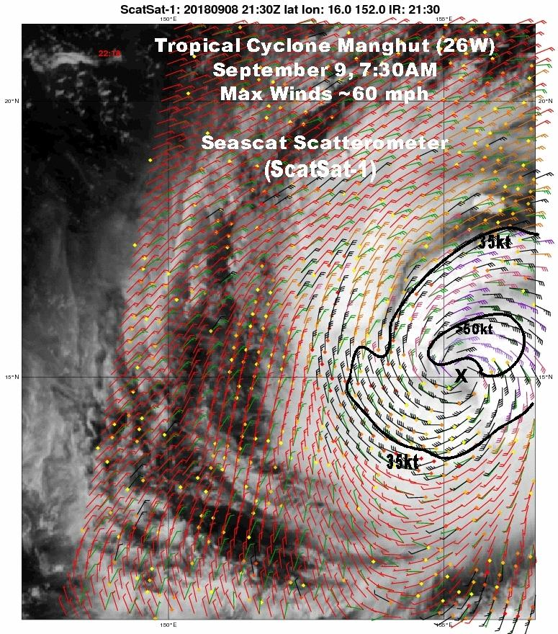Figure 8: ISRO ScatSAT-1 scatterometer data provided by Royal Netherlands Meteorological Institute (KNMI) a partner of the OSI SAF EUMETSAT organization. Positioning/wind structure of TS Mangkhut are clearly depicted as it approaches the Marianas

**Contact Information:**

|  |  |  |
| --- | --- | --- |
| Member: | USA - Guam | USA - Hawaii |
| Name of contact for this item: | Roger Edson | Robert Ballard |
| Telephone: | (671) 472-0948 | (808) 973-5274 |
| Email: | roger.edson@noaa.gov | robert.ballard@noaa.gov |